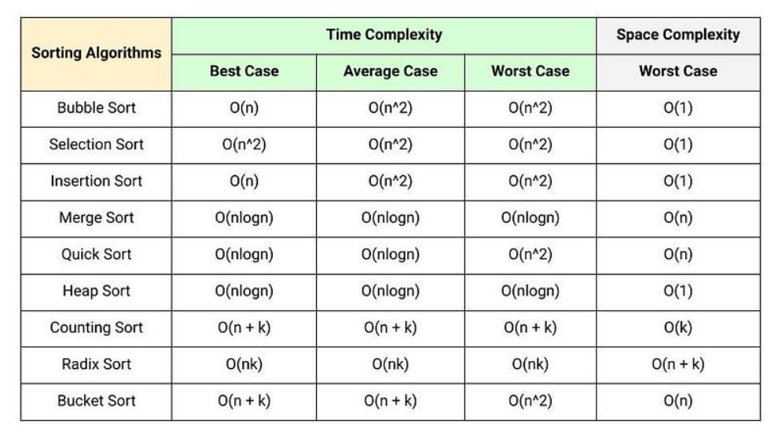
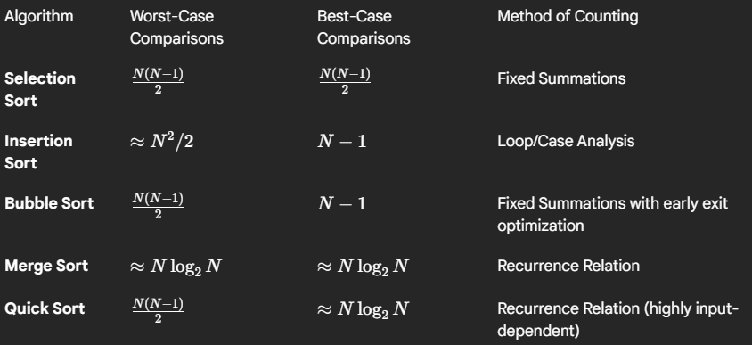
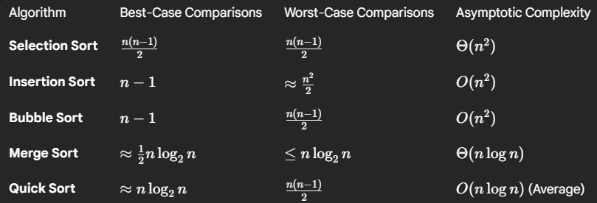

Comparison-Based Sorting Algorithms
They rely on comparing elements to determine their relative order, have a theoretical lower bound of Ω(𝑛log𝑛) comparisons in the worst case, where 𝑛 is the number of elements.

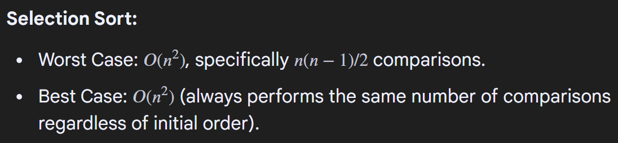
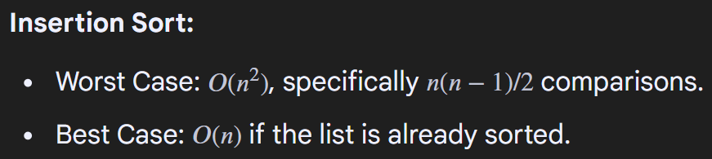
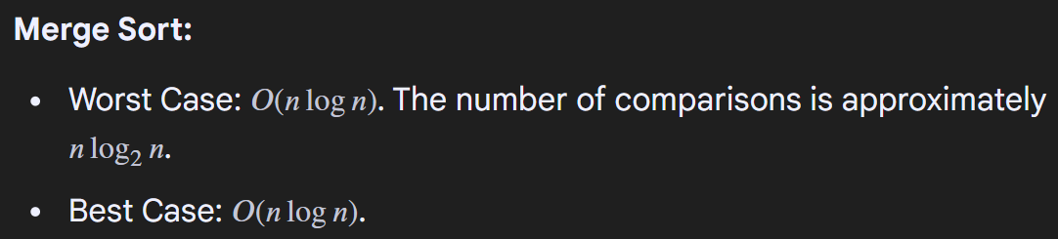
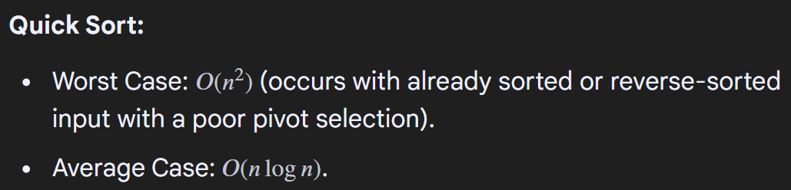
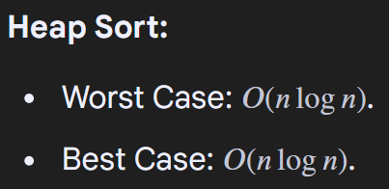
Non-Comparison-Based Sorting Algorithms
Algorithms like Counting Sort or Radix Sort do not rely on comparisons and can achieve better time complexities, sometimes even 𝑂(𝑛), but they have limitations on the data they can efficiently sort (e.g., integers within a specific range).
Counting Comparisons
To count the comparisons made by a sorting algorithm, a counter variable can be incremented each time a comparison operation is performed within the algorithm's code. This provides empirical data on the number of comparisons for specific inputs.

